  - Screen Shots

1.1 Screen 1: Employee Search Screen

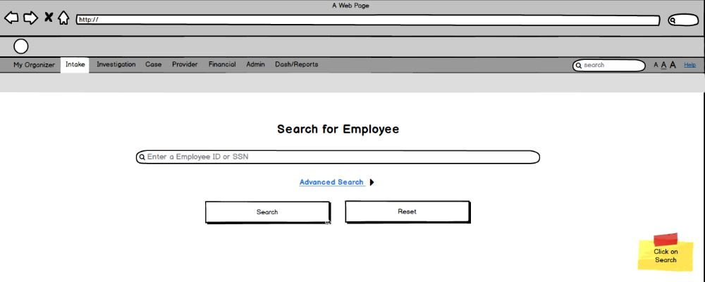

    - Screen Fields
 | Display Name |  |  | Size |  |  |  | To Be
Class.Attribute Name | Display Name | Type | Align | Size | Read | Calculation | Edit Mask | UI Validation
 | Display Name |  |  | Size | Only
 | Employee ID or SSN search | Search Box |  |  |  |  |  | Employee ID or the SSN can be entered to search for an employee. It’s a 6 digit or a 9 digit search.

1.1.2 Action Buttons/Hyperlinks
Label | Type | On Click Action/Navigation
Advanced Search | Expandable/Collapsible link | Advanced Search Menu will be displayed with additional search criteria (Screen 2)
Search | Button | Search Results will be displayed as per the search criteria
Reset | Button | The search criteria entered will be erased to default values

  - Screen 2: Advanced Employee Search Screen
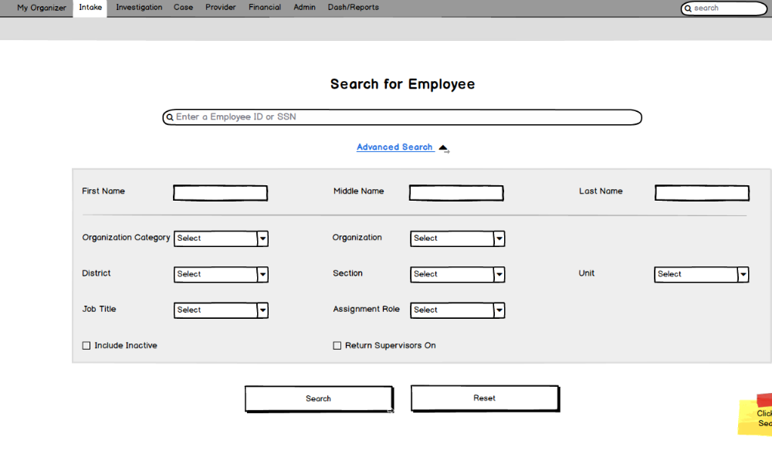

1.2.1 Screen Fields

 | Display Name |  |  | Size |  |  |  | To Be
Class.Attribute Name | Display Name | Type | Align | Size | Read | Calculation | Edit Mask | UI Validation
 | Display Name |  |  | Size | Only
Person.firstName | First Name | Text | L | 40 | F
Person.middleName | Middle Name | Text | C | 40 | F
Person.lastName | Last Name | Text | R | 40 | F
Agency.agencyCategoryCode | Organization Category | Dropdown List | L | 100 | F
Agency.AgencyName | Organization | Dropdown | L |  | Read only |  |  | List of Organizations based on user selection in Organization Category.
Emplolyee_Work_History.SectionCode | Section | Dropdown List | L | 100 | F |  |  | Only Display sections associated with the user selected Organization and District.
Employee_Work_History.DistrictCode | District | Drop down list |  |  |  | Domain Code:  District
AgencyUnit.AgencyUnitName | Unit | Dropdown List | L | 100 | F |  |  | Only Display Units associated with the user selected Organization, District, & Section
EmployeeWorkHistory.JobTitleCode | Job Title | Drop Down List | L | 100 |  | Domain Code=’JobTitle’
Role.RoleName | Assignment Role | Dropdown List | L | 100 | F |  |  | Only display values where the Assignment flag is true.
Employee.TerminationDate | Include Inactive | Checkbox | L | N/A | F |  |  | Returns rows with employees where terminated date does not equal null
EmplyeeWorkHistory.UnitSupervisorID | Return Supervisors Only | Checkbox | L | N/A | F |  |  | When checked the search results will only return employees that are supervising a Team

1.2.2 Action Buttons/Hyperlinks
Label | Type | On Click Action/Navigation
Include Inactive | Checkbox | Checking the inactive box and clicking on Search, will display the inactive employees on the search results
Return Supervisors Only | Checkbox | When checked the search results will only return employees that are supervising a Team
Search | Button | Search Results will be displayed as per the search criteria
Reset | Button | The search criteria entered will be erased to default values

3: Employee Search Result screen

Screen 3.1 Through Quick search:

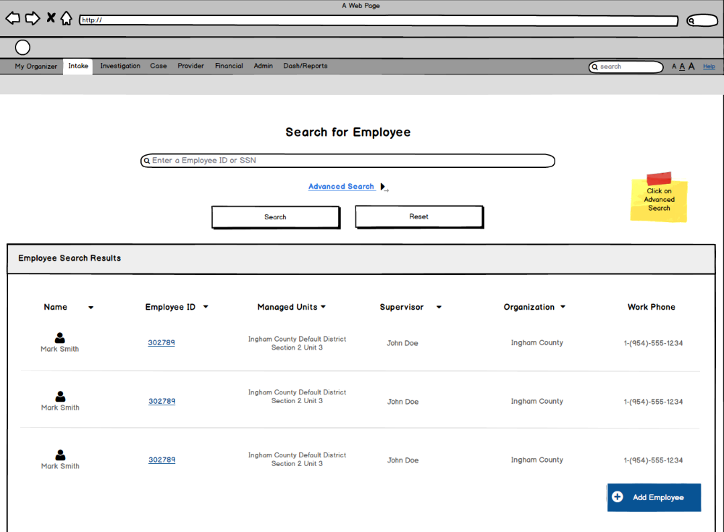

Screen 3.1: Employee search result screen through Advanced search:

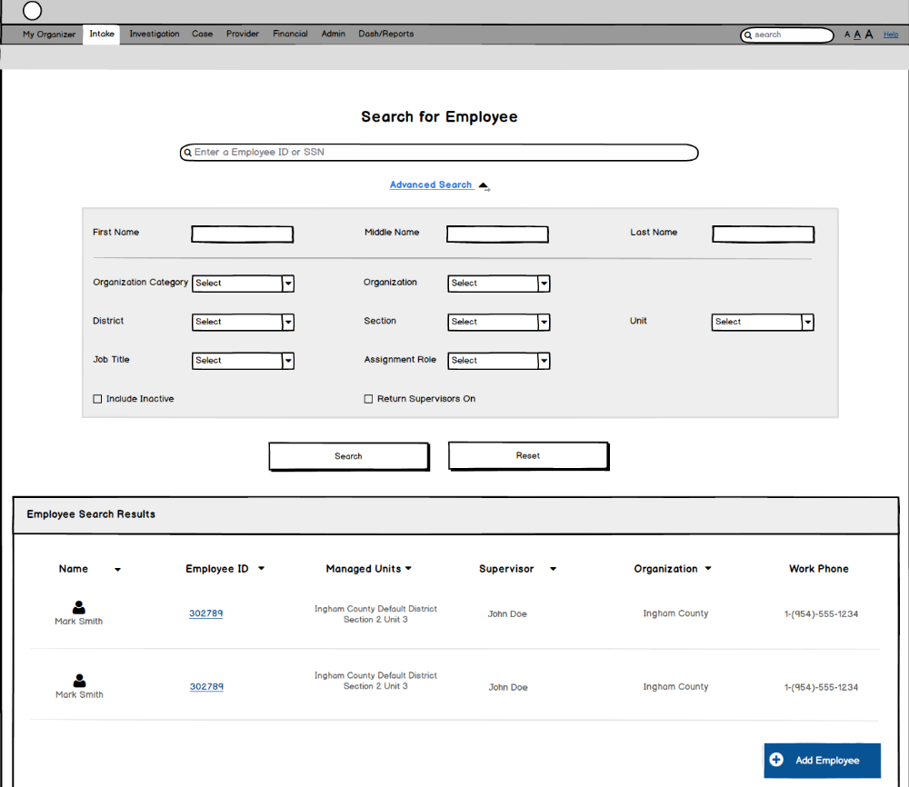

1.3.1 Screen Fields

 | Display Name |  |  | Size |  |  |  | To Be
Class.Attribute Name | Display Name | Type | Align | Size | Read | Calculation | Edit Mask | UI Validation
 | Display Name |  |  | Size | Only
 | Employee Search Result | Header
Person.firstName, Person.lastName, Person.middleName | Name | Text | L | 100 | T
Employee.employeeId | Employee ID | Link | L |  |  |  |  | Link takes us to basic details of the employee. For Sprint 3, this will be a static one.
AgencyUnit.agencyUnitName | Managed Units | Text Field | L | 50 | T
Person.firstName, Person.lastName, Person.middleName | Supervisor | Display Text | L | N/A | T |  |  | Derive data from employee’s current job
Agency.agencyName | Organization | Display Text | L | 100 | T
PartyContactMedium.partyContact | Work Phone | Display Text | L | 130 | T

1.3.2 Action Buttons/Hyperlinks
Label | Type | On Click Action/Navigation
Select | Link | The employee is selected and user return to the calling user story- CF02
Employee ID | Hyperlink | Context-sensitive hyperlink that returns control to the calling page. Opens the employee basic screen  (This will not be implemented for Sprint 3)
Search | Button | Search Results will be displayed as per the search criteria
Cancel | Button | Returns to calling use case with no returned results.  Button only appears when this screen is accessed as a sub-function from another use case.

- Story
As a supervisor, I want to search for employee records so that I can maintain Employee Information.

- Notes

3.1 Demo Steps

Pre-condition for this user story: Employee details/records already exist

The employee search is invoked as part of CF02
Flow 1: To search for an employee – Quick Search
- Step 1: Login to the USFN application with the following credentials
  - Username: samweaver
  - Any Password works.
‘My Organizer’ screen is displayed after successful login.
- From left hand menu navigate to Administration – Staff – Intake/On-Call employee (CF02 is launched)
- Enter the mandatory search criteria and click on search button.
The list of on-call employees is displayed for the search criteria or there may be no records retrieved.
- Click on ‘Add Intake/Add On-Call Employee’ button.
- Employee search screen is launched. (Screen 1)
- Enter the search criteria for search of an employee in Screen 1 with the Employee ID (or SSN) in the Quick search box.
- Click on Search.
Employee search results screen is displayed matching with the search criteria. (Screen 3).

Flow 2: Search for an employee using Advanced Search
- Step 1: Login to the USFN application with the following credentials
  - Username: samweaver
  - Any Password works.
‘My Organizer’ screen is displayed after successful login.
- From left hand menu navigate to Administration – Staff – Intake/On-Call employee (CF02 is launched)
- Enter the mandatory search criteria and click on search button.
The list of on-call employees is displayed for the search criteria or there may be no records retrieved.
- Click on ‘Add Intake/Add On-Call Employee’ button.
Employee search screen is launched. (Screen 1)
- Click on the Advanced Search link
Advanced Search criteria section is expanded and displayed (Screen 2)
- Organization category and Organization will be pre-populated with the values as per the CF02 search criteria.
- Enter the other details and click on Search
Employee search results screen is displayed matching with the search criteria. (Screen 3).
- Select the employee by clicking on select link and continue with the CF02

- Acceptance Criteria

# | Requirement | Execution Event | Status
1 | If Employee ID or SSN are used as search criteria, the search will do an exact match search on the entered data (i.e. no wild card search permitted).  Employee Search results should be as per the criteria mentioned | On clicking Search
2 | If Employee ID or SSN are used as search criteria, all other fields will be ignored during the search. | On clicking Search
3 | The list of Organizations will be derived from the Agency table that matches the user entered Organization Category and displayed in the drop down in alphabetical order. | Display
4 | When a call is made to this Use Case from CF02 – Identify On-call Staff the Organization Category and Organization data will be passed from CF02. Also, the ‘Include Inactive’ field will be unchecked and disabled. Finally, the ‘Add Employee’ button will be hidden. | Display

- Seed Data
Dropdown data.

No. | Field Name | Domain Code | Short Desc |  |  | Ref Data Code
1 | Organization Category | AgencyCategory |  | Central Intake | CENTRALINTAKEORG
1 | Organization Category |  |  | Central Office | CENTRALOFFICEORG
1 | Organization Category |  |  | DHS Residential | DHSRESIDENTIAL
1 | Organization Category |  |  | DHS County Office | DHSCOUNTY OFFICE
1 | Organization Category |  |  | Other | OTHER
1 | Organization Category |  |  | Other State Agency | OTHERSTATEORG
1 | Organization Category |  |  | Court | COURT
1 | Organization Category |  |  | Private Agency | PRIVATEAGENCY
1 | Organization Category |  |  | Tribe | TRIBE
2 | District | District |  | Values are too numerous and complicated to display here. See MiSACWIS Reference Data Spreadsheet. | Values are too numerous and complicated to display here. See MiSACWIS Reference Data Spreadsheet.
3 | Section | Section |  | Values are too numerous and complicated to display here. See MiSACWIS Reference Data Spreadsheet. | Values are too numerous and complicated to display here. See MiSACWIS Reference Data Spreadsheet.
4 | Job Title | JobTitle |  | Administrative/Technical Support | ADMINISTRATIVETECHSUPPORT
4 | Job Title |  |  | Case Aide/Transporter | CASEAIDETRANSPORTER
4 | Job Title |  |  | Community Resource Coordinator | COMMUNITYRESOURCECOORD
4 | Job Title |  |  | Contact Administrator | CONTACTADMINISTRATOR
4 | Job Title |  |  | Education Planner | EDUCATIONPLANNER
4 | Job Title |  |  | Foster Care Placement Worker | FOSTERCAREPLACEMENTWORKER
4 | Job Title |  |  | Health Liaison Officer | HEALTHLIAISONOFFICER
4 | Job Title |  |  | Intake Worker | INTAKEWORKER
4 | Job Title |  |  | Michigan Youth Opportunity Initiative | MICHIGANYOUTHOPPORTUNITY
4 | Job Title |  |  | Permanency Planning case Conf. | PERMPLANCASECONF
4 | Job Title |  |  | Permanency Planning Assistant | PERMPLANASSISTANT
4 | Job Title |  |  | Recruitment Workers | RECRUITMENTWORKER
4 | Job Title |  |  | Staff in CWTI | STAFFINCWTI
4 | Job Title |  |  | Title IVE/CWFS | TITLEIVECWFS
4 | Job Title |  |  | Adult Protective Services | ADULTPROTECTIVESERVICES
4 | Job Title |  |  | Adoption | ADOPTION
4 | Job Title |  |  | Children's Protective Services | CHILDRENPROTECTIVESERVICES
4 | Job Title |  |  | Foster Care | FOSTERCARE
4 | Job Title |  |  | Indian Outreach | INDIANOUTREACH
4 | Job Title |  |  | Juvenile Justice | JUVENILEJUSTICE
4 | Job Title |  |  | Prevention | PREVENTION
4 | Job Title |  |  | Therapist | THERAPIST

